**Excel Assignment - 11**

*1. Use the below table for the following Questions.*

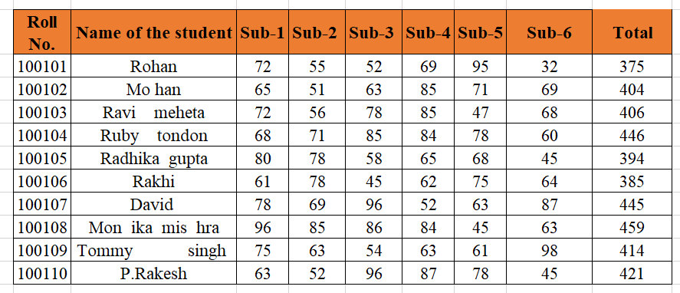

*1. Find the Minimum Marks and Maximum marks scored by each student.*

i ) For Minimum Marks formula is = Min(Number1,number2……)

ii ) For Maximum Marks Formula is = Max(Number1,number2……)

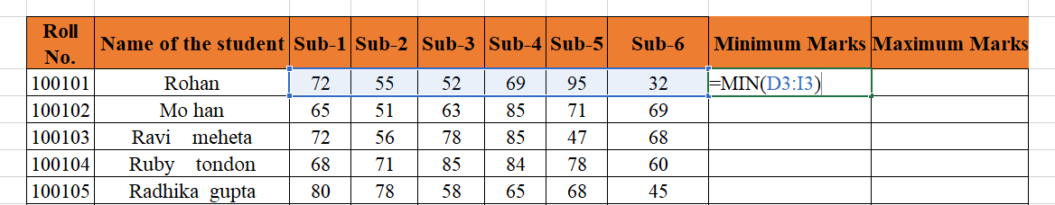

iii) Drag the formula for the all the rows

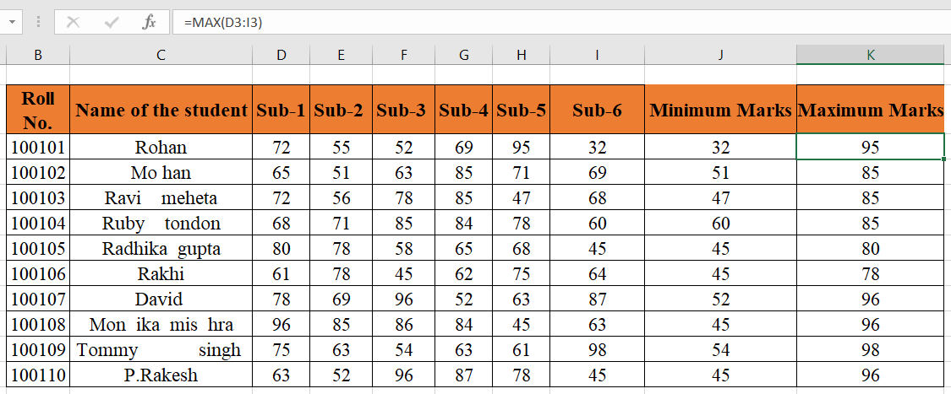

*2. Calculate the totals for each student, use conditional formatting to highlight the top students who have scored more than 480.*

1. To calculate the total, formula is =Sum(Number1,Namber2,……….)

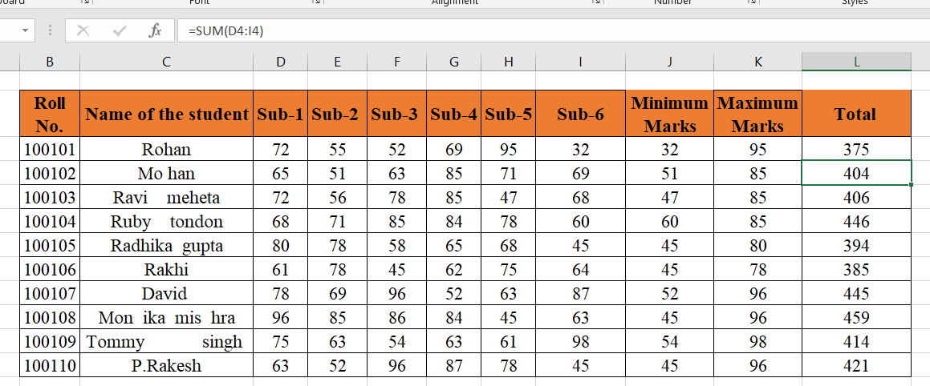

1. For conditional formating ,
2. select the column for conditional formating.

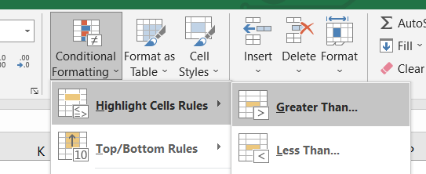

1. By selecting Grater than, enter the value 480 and give the highliting condition.

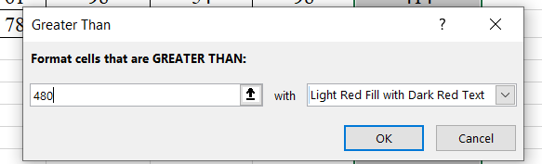

C) There is no value more than 480 so there will be no highlighting.

*3. Calculate the length of the names of each student.*

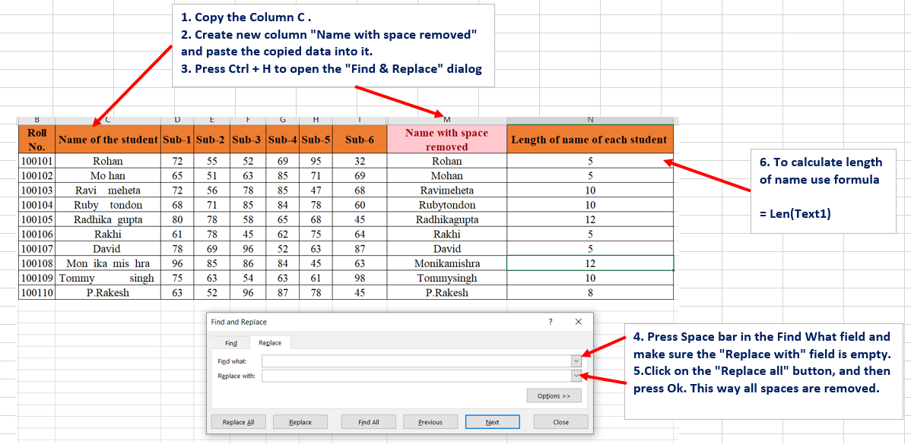

*4. Replace the Name Rakhi with Rocky. Use Formulas*

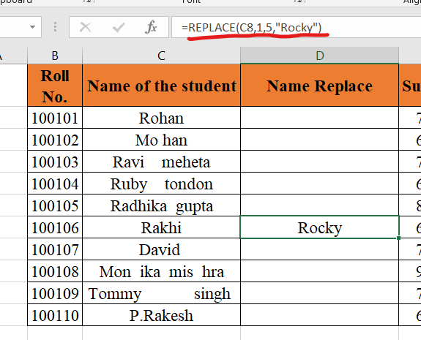

*5. Combine the Roll Numbers and Names. Use formulas. The end result*

*should look like below.*

*100101Rohan*

This is done by using Concat function and then drag formula below. Refer Column E for Results.

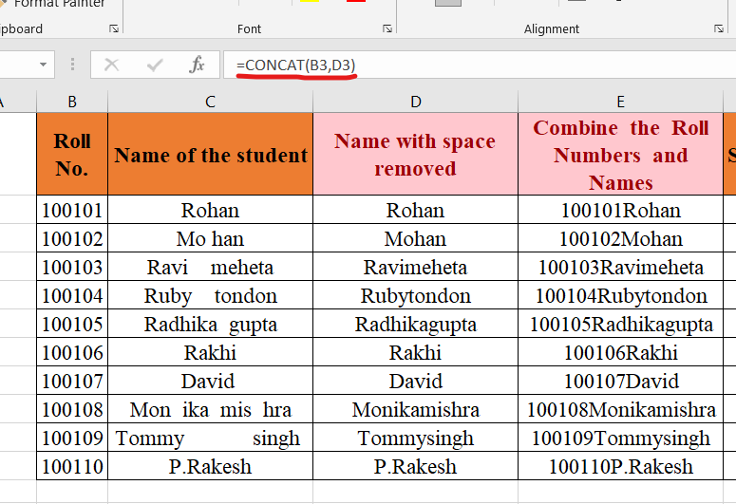

*6. As you can see that some names have spacing issues. Use Formulas to correct that spacing. Also ensure that the names and surnames start with a capital letter.*

*1.* To Add space , Concat formula is used :As each name has different characters we need to change formula for each name.

2. To make the names and surnames start with a capital letter, “Proper” formula is used .

